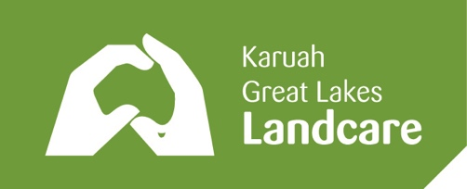
Karuah & Great Lakes Landcare Inc (KGLL)
PO Box 3, NABIAC, NSW 2312
kgl.landcare@gmail.com

A volunteer-run association which supports and represents community-based, rural and urban sustainable land management member groups in the catchments of the Great Lakes & the Karuah River

INDIVIDUAL MEMBERSHIP APPLICATION FORM

Name:

Property Address
Street Address:

Suburb & Post Code:

Postal address (if different from above)
Street Address:

Suburb & Post Code:

Email:

Phone: Mobile:

If known, my local subgroup is: …………………………………………………..………………………

Annual subscription per individual for 1 January to 31 December is $10 or $25 for 3 years
Your membership entitles you to be associated with any of the member locality / interest groups
Members are regularly notified by email of events, information and opportunities

To renew, simply pay your subscription by either method below.

New members email or post this form to the address above and pay by either method below.

Pay your subscription either:

- In person or online, into KGLL’s bank account at Regional Australia Bank:

BSB 932000 Account 500078999
Account Name Karuah Great Lakes Landcare
with your name as the bank reference, so that we can identify your payment

- Post a cheque or cash to the address above

Date ………………...…………

